**Management Plan: Sprint #1**

**Gnatt Chart:**

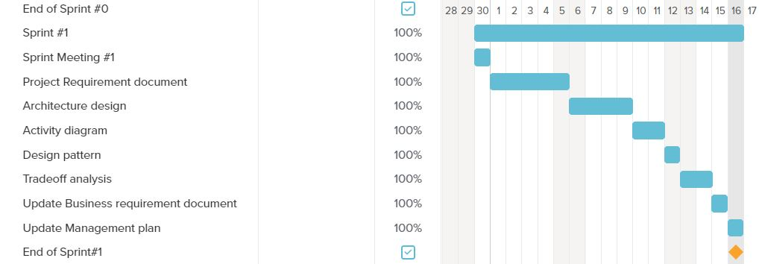

In this sprint, we worked on the Product requirement document and Design and Architecture Document. We updated the Business requirement document and management plan. We created mockups for homepage, pets page and the features for all the other pages with a tab on the navigation bar.

**Code Development velocity calculation:**

In this sprint, we had planned to finish 35 points worth tasks and we were able to finish it on time.

**Sprint Retrospective:**We finished all the tasks that were planned for this sprint on time. 35 points were planned in this sprint. We were able to complete those 35 points on time. Commitment per person every week= 5hrs.Team commitment per sprint= 5hrs *6 people * 3 weeks = 90hrs. Planning on completing 35 points in the next sprint as well. The burndown chart looked linear. We finished the tasks at the right pace. The right amount of tasks were assigned in this sprint which could be completed in the given timeframe. We learned the different architectural designs and concluded the best architecture design for our web application. A lot of time was spent working on the trade-off analysis with some time spent on the interface design.

For the next sprint, we need a more detailed understanding of all the machine learning models, so we can finally decide on a good alternative to choose from.